**PROJECT-NAME: ZOMATO**

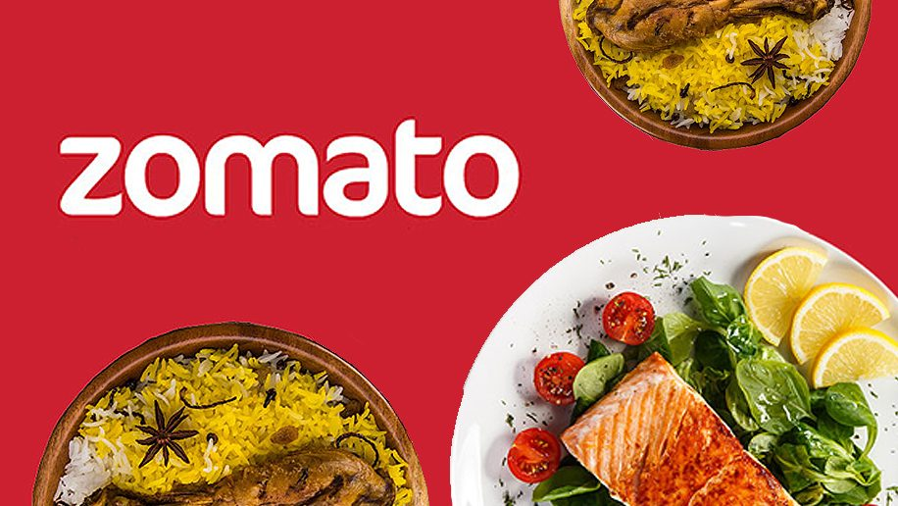

**\*OVERVIEW:**

Zomato is **an Indian multinational restaurant aggregator and food delivery company** founded by Deepinder Goyal and Pankaj Chaddah in 2008. Zomato provides information, menus and user-reviews of restaurants as well as food delivery options from partner restaurants in select cities.

1. **HOME PAGE:**

# LOGO

# PRODUCTS

# SEARCH BAR

# DEALS - (IMAGES)

# FEATURED - (IMAGES)

# FOOTER – ( CONTACT US , HELPLINES , BRIEF DESCRIPTION

ABOUT THE COMPANY , SOCIAL-MEDIA HANDLE

ICONS , LINK TO MOBILE APP )

1. **REGISTRATION FORM:**

# NAME

# E-MAIL ADDRESS

**3. MAIN PAGE:**

# FILTERS - (POPULARITY, (RATING: HIGH TO LOW), (COST: LOW TO HIGH),(COST HIGH TO LOW))

# DELIVERY TIME

# CUISINES(IT IS TYPE ONE KIND OF FILTER)

# DINNING OUT =IT WILL GIVE THE LIST OF RESTAURANTS

# NIGHTLIFE( Explore curated lists of top restaurants, cafes, pubs, and bars , based on trends)

1. **PAYMENT PAGE:**

# ADDRESS SELECTION

# PAYMENT METHOD - (PHONEPE , GOOGLE PAY , BHIM UPI ,

COD , CREDIT/DEBIT CARD , NET

- BANKING , EMI , PAYTM)